|  |  |  |  |  |  |
| --- | --- | --- | --- | --- | --- |
| Date | November 29, 2022 | | | Tester Name | Shahabuddin Syed |
| Environment | Penfax - Test | | | Login used |  |
| Operating System | Windows | Version: | Update: | | |
| Software Used | Edge | Version: | Update: | | |
| Select Software | Version: | Update: | | |
| Release version | 22.4.1 | | | | |
| Title | E23.01 Declaration of Unit Values | | | | |
| Test Type | Regression | | | | |
| Test Scenario | Check that Declaring of unit values was correct for weekday, weekend and stat holiday | | | | |
|  |  | | | | |
| Expected Results | Weekday – batch ran successfully  Weekend – batch fails as no unit values to apply  Stat – Batch will fail as no unit values apply  Confirm that the unit values in the Declaration of unit values matches in a members account, how it’s viewed on PENWEB, and on the PEPP website to confirm results.  Check a few different members with a few different funds to confirm. | | | | |
| Pass/Fail | Pass | | | JIRA# | N/A |

Batch processes, type: declaration of unit values:

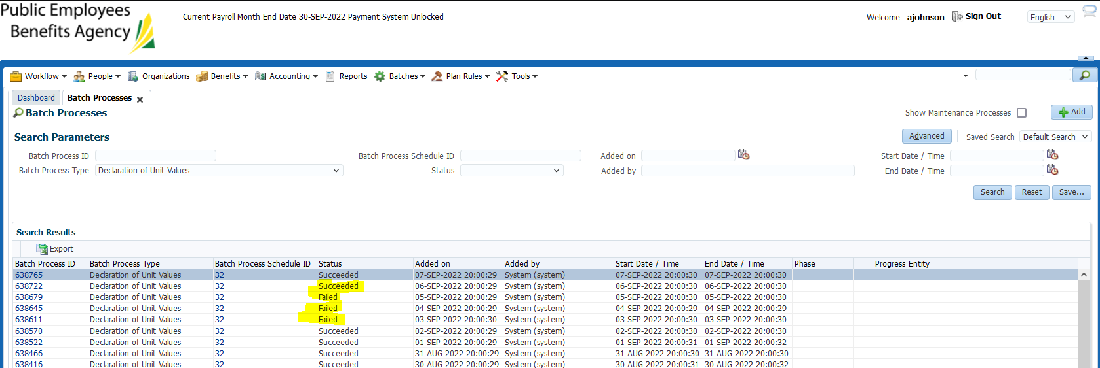

Nov 28th – Weekday – batch succeeded

Nov 27th – Weekend – batch failed

Nov 26th – Weekend – batch failed

Batch succeeded, Nov 25th:

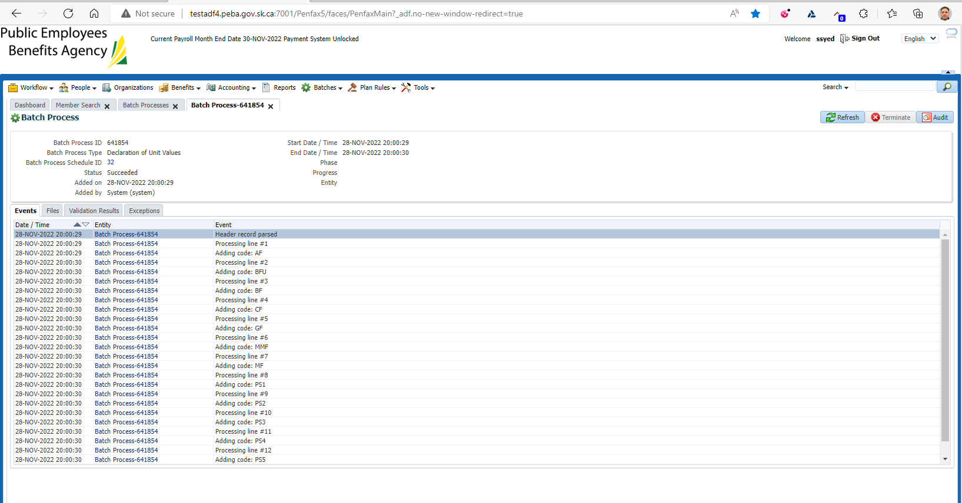

Go to plan rules/DC fund management & can confirm current day’s unit values here:

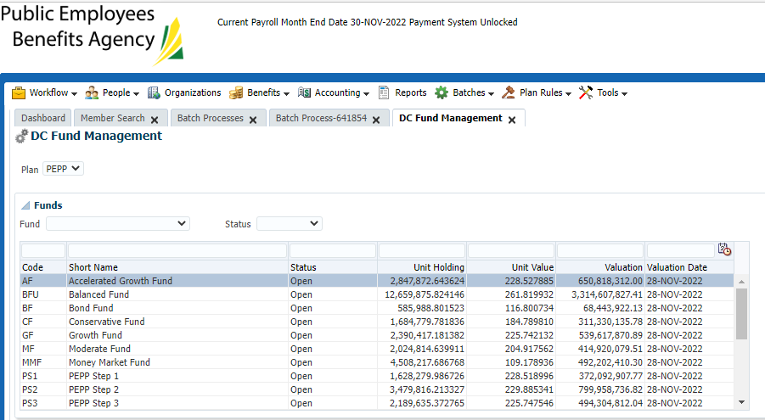

SID 241459

November 28, 2022:

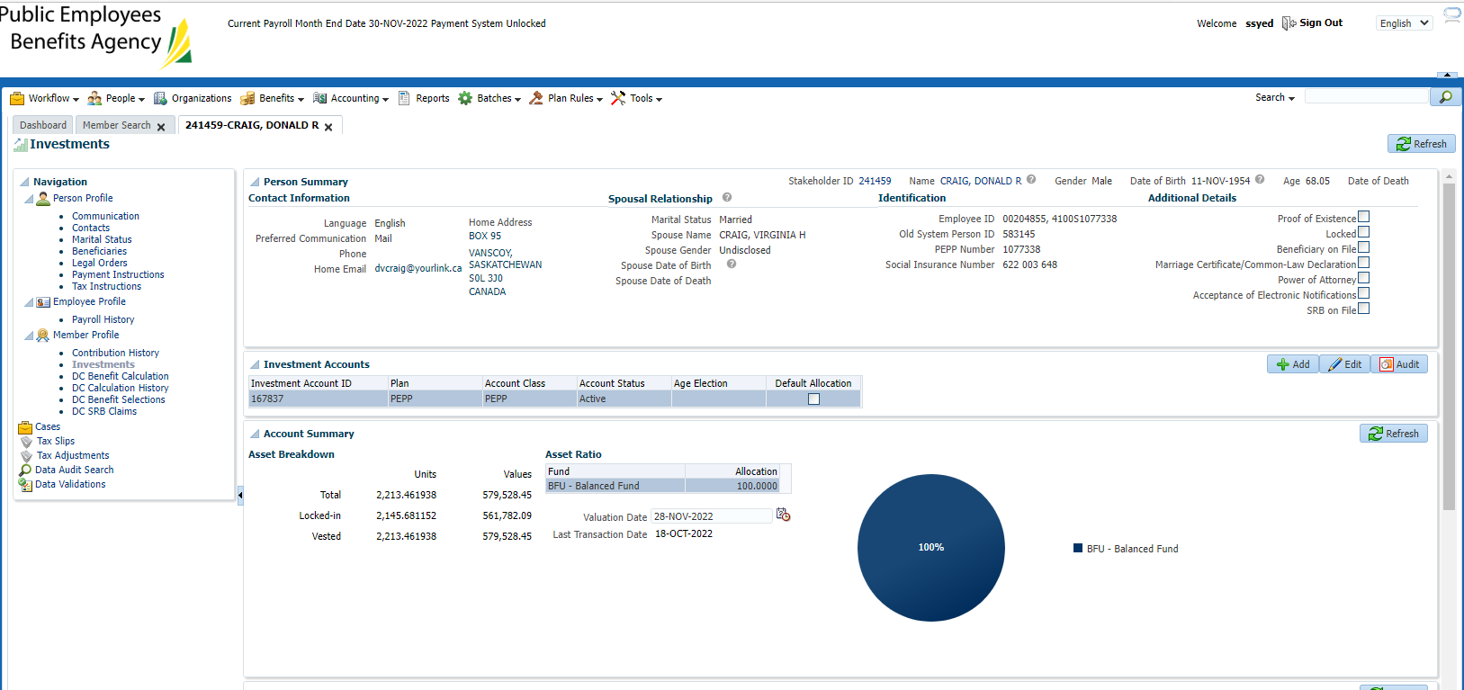

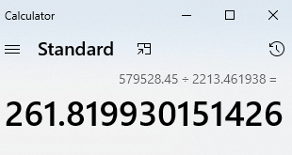

November 25, 2022:

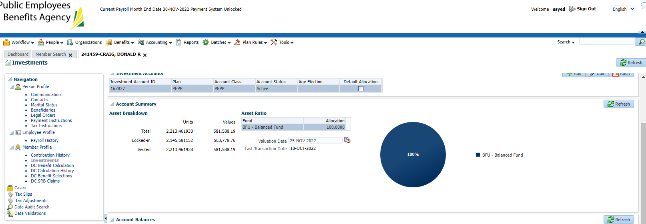

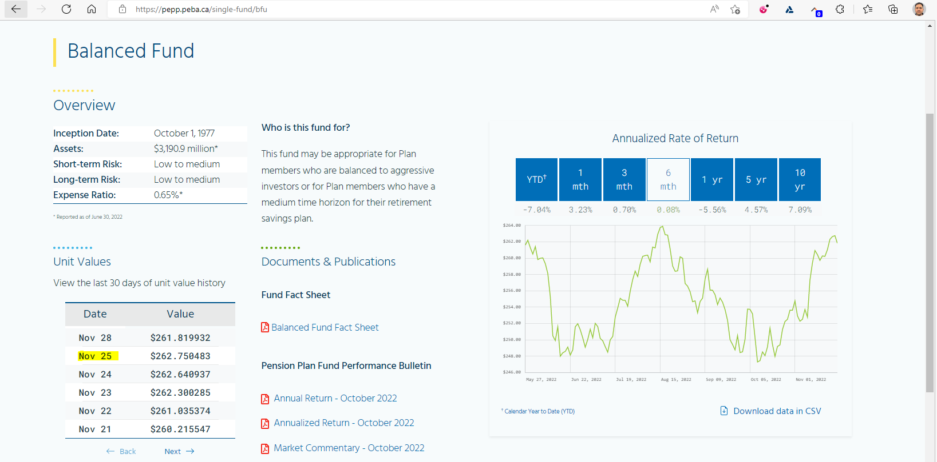

Divided balance by number of units to confirm the unit value used:

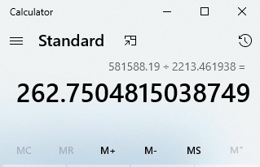

Checking the PENWEB view:

Go to the Admin portal, search MKEY & click support mode:

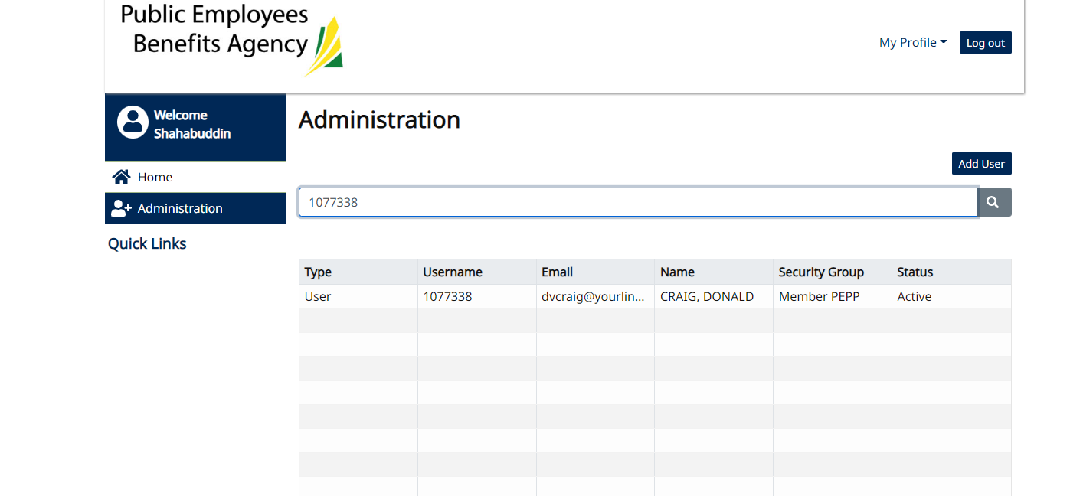

Click on my Account Balance from the home screen which brings you to this page:

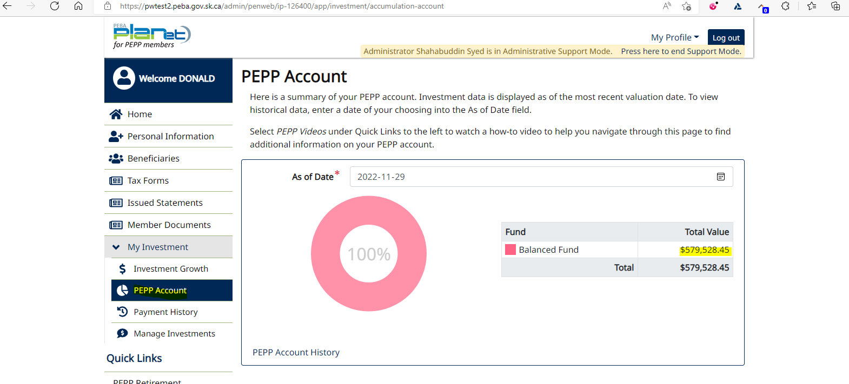

Change the as of date on this screen to November 25th & click somewhere in the highlighted area to view the unit values pop up box.

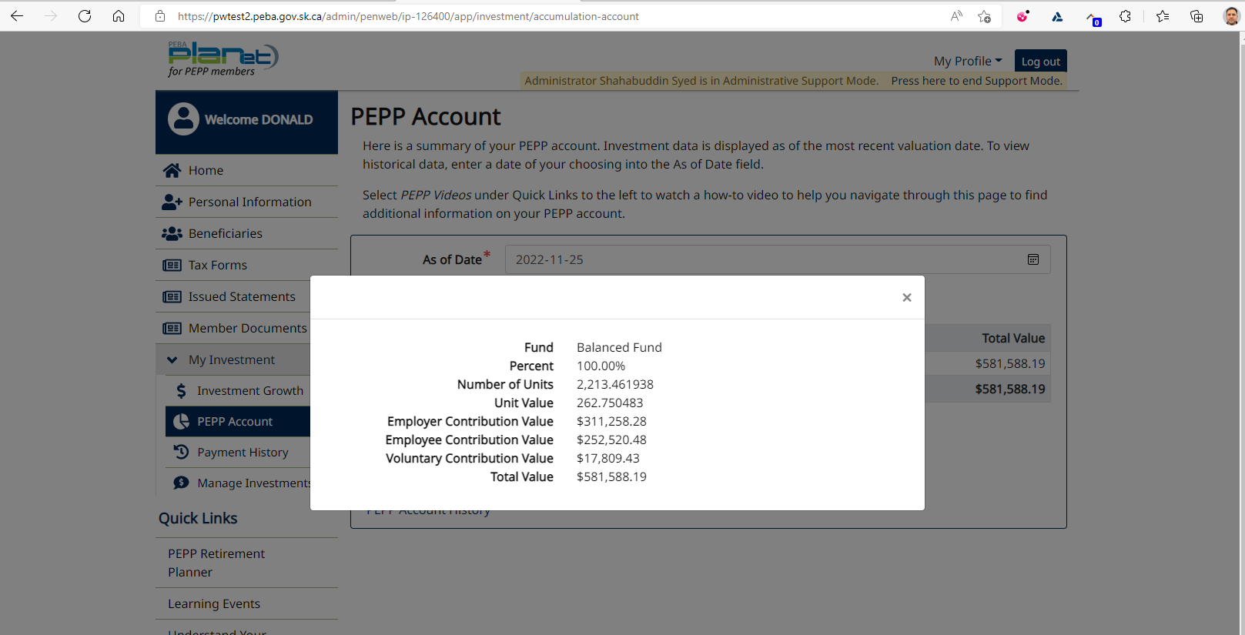

Confirmed that the unit value on PENWEB matches Penfax & website

SID: 480057 (Nov 28, 2022- Step1) - passed

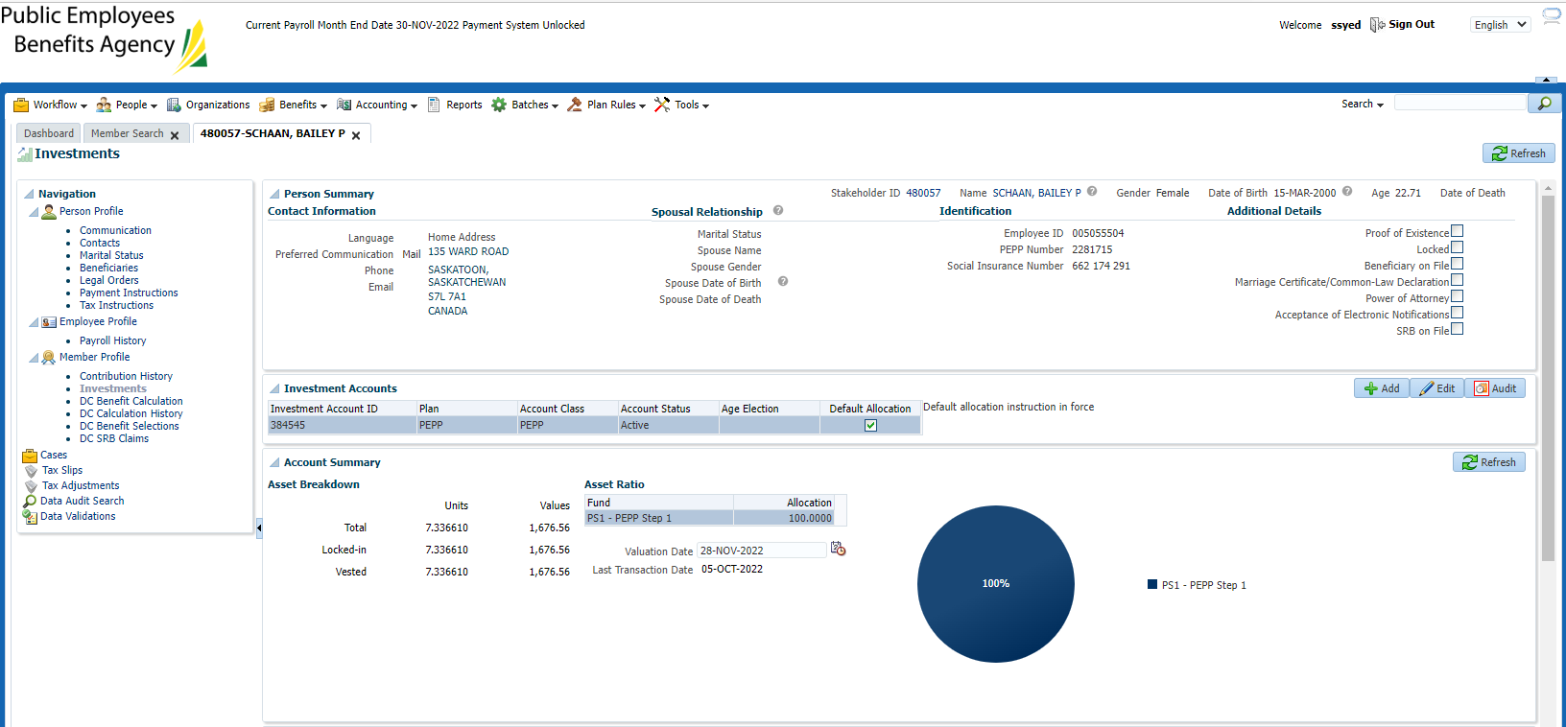

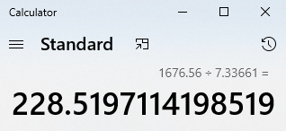

(ok, rounding issue as there is a small dollar amount)

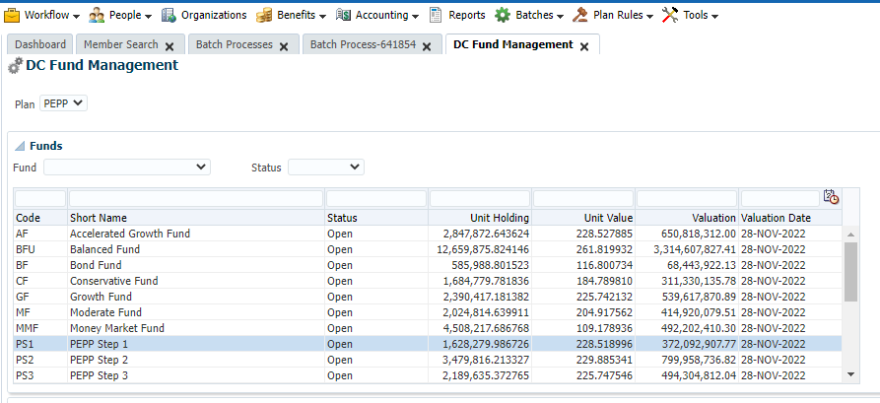

SID: 312450 (Nov 28 – Step 5) - passed

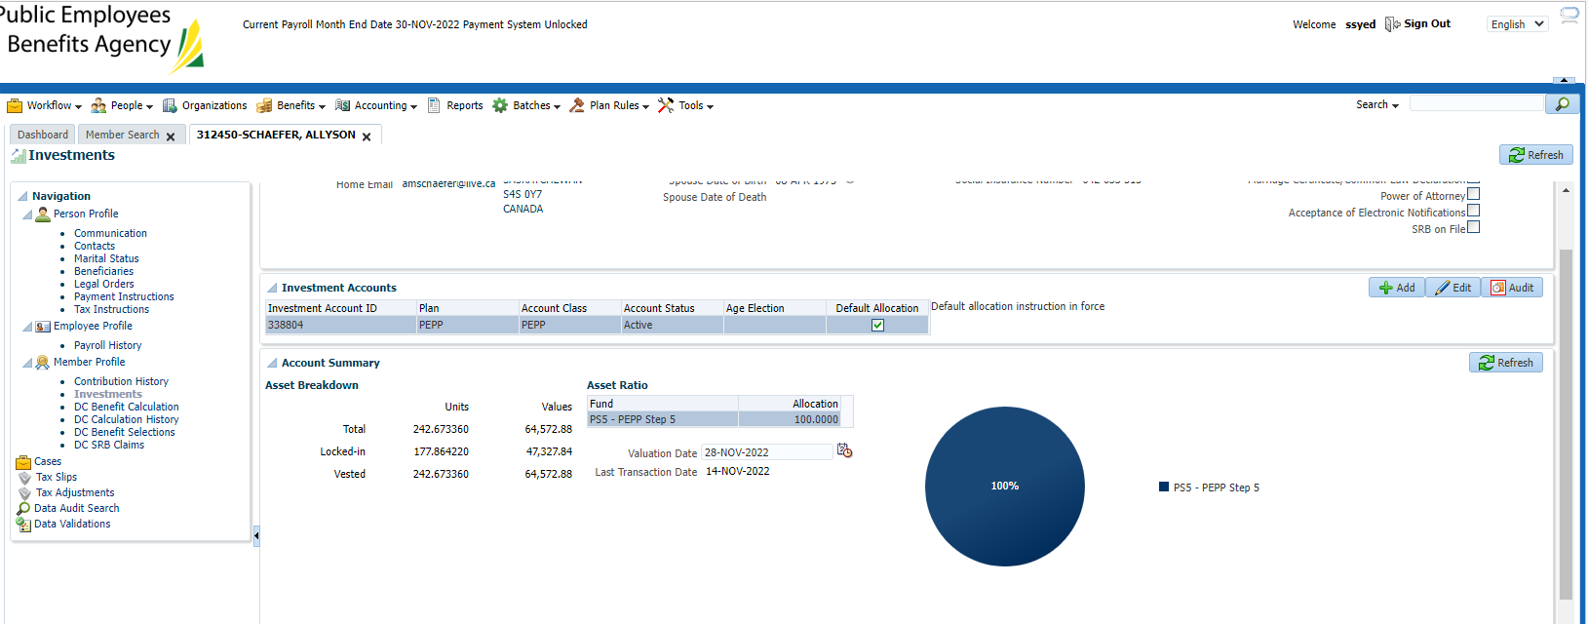

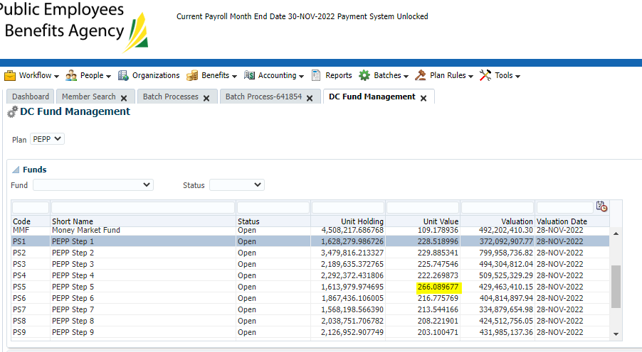

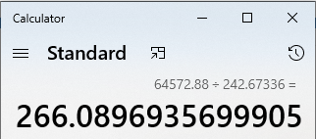

SID: 321726 (Step 1 -retest) - passed

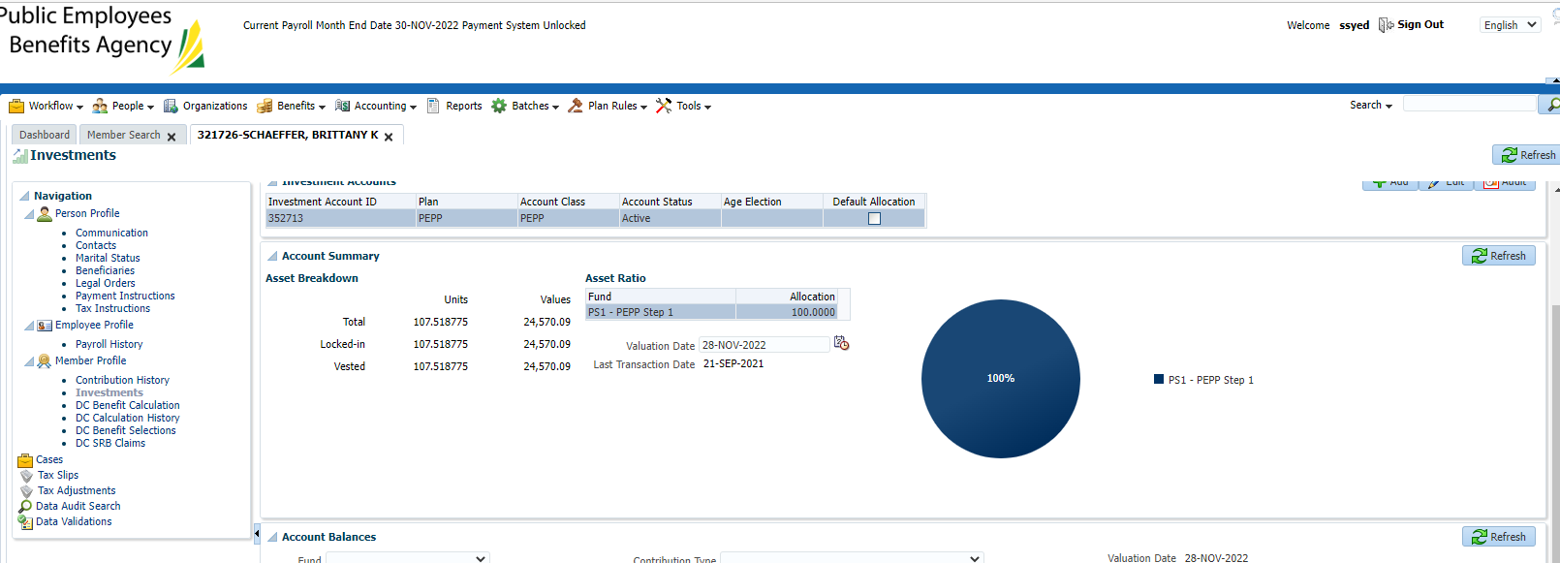

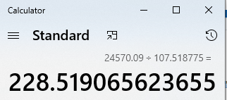 ok, showing the exact number with a higher account balance.

